**Panama City Little League Boundary Map**

**Bay County Map**

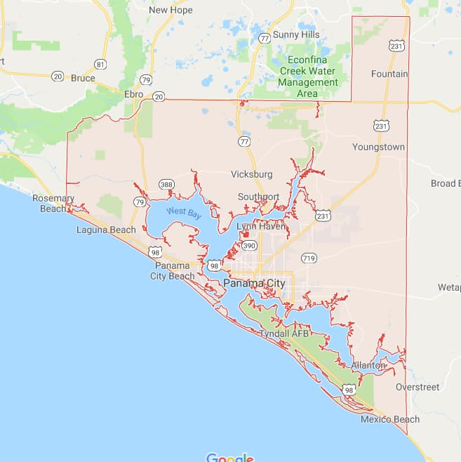

**Gulf County Map**

**Panama City Little League Boundary Map**

City of Panama City is requesting Little League participation. Panama City, Florida operates under District 1 – Northwest Panhandle of Florida. Panama City Little League is requesting to divide several zip codes into one redefined District under Panama City Little League.

Redefined District would include Bay County and Gulf County, Florida. Cities under Bay and Gulf Counties include: Panama City Beach, Lynn Haven, Southport, Panama City, Callaway, Springfield, Parker, Bayou George, Tyndall Air Force Base, Mexico Beach, Port St Joe, Wewahitchka, and Youngstown.

Bay County and Gulf County zip codes included into new District: 32401, 32403, 32404, 32405, 32407, 32408, 32409, 32413, 32444, 32456, and 32466.

Boundary Marker includes major US Major Highways. Boundary map would begin in Bay County with intersection of Highway 98 and Highway 79 traveling north to Highway 20. The Intersection of Highway 20 and Highway 79 traveling east on Highway 20 into Gulf County to Highway 73. Intersection of Highway 20 and Highway 73 traveling south to Highway 71. Intersection of Highway 71 and Highway 73 traveling south to Highway 386. Intersection of Highway 386 and Highway 71 traveling southwest, into Bay County, to Highway 98. Intersection of Highway 98 and Highway 386 traveling west on Highway 98, over the Hathaway Bridge, until reaching beginning of Boundary map of Highway 79.